Game Concept:
The game functions like a call of duty multiplayer game. In the game players will have the opportunity to vote on certain game modes like capture the flag, team deathmatch etc. Each game mode is unique.
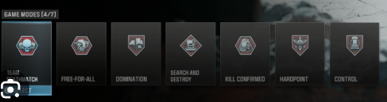
Example of game modes from call of duty

Game flow
The game has no menu screen. Instead, the flow of the game goes like this: When a player joins the game, they go into a lobby full of players. This lobby may already have a match in progress, or they may be voting on a new game mode. The player will also be met with a menu screen if a game is in progress. Here they may switch out their weapons (and buy new ones in the future) and press a button to participate.
  - Voting on a new game mode
When a game in progress ends it will be time to vote on a new game mode. Players will be given three options. Whichever option gets the most votes will be chosen
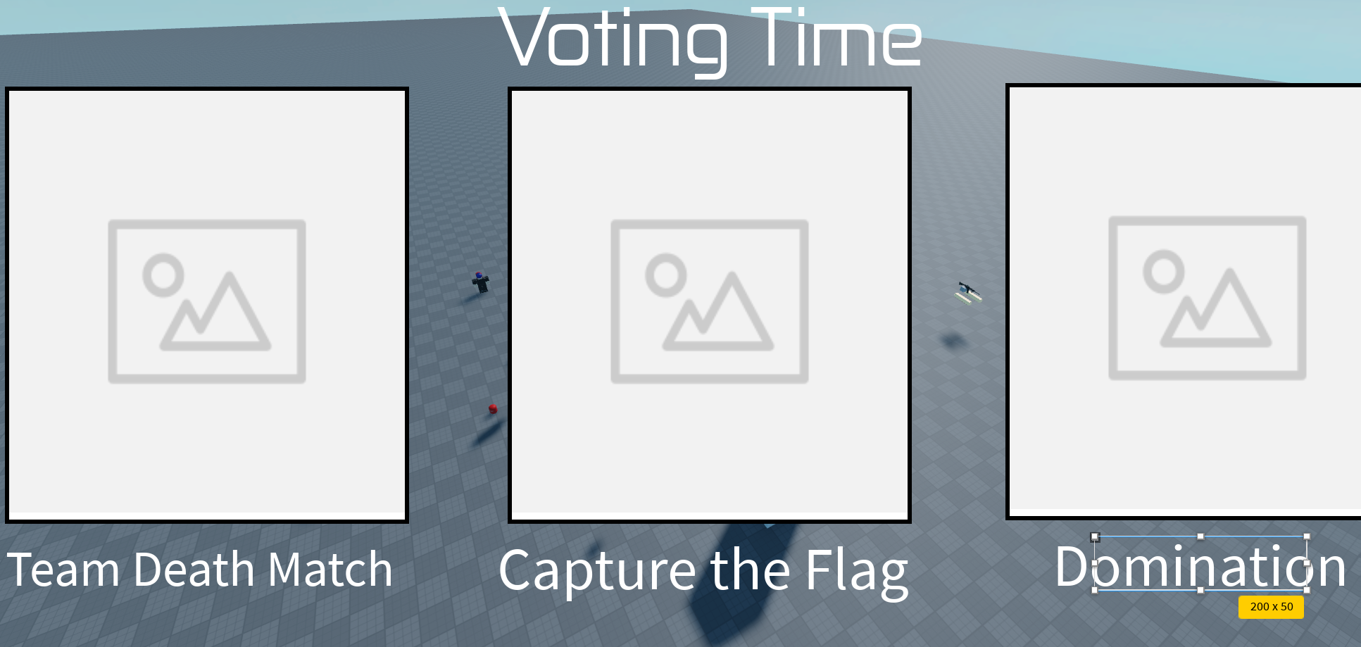
What the player’s screen will look like when it is time to vote
  - Games in progress
After voting on a new game mode the game will load all the scripts and props needed for the game mode. Game modes will last 10-20 minutes depending on which one has been selected.

Systems the game needs
- Weapons system
- Voting system
- GUI for game modes (like score boards displayed on players’ screens)
- Menu screen system
- Main GUI system

